Community Council Report

Llandow Ward

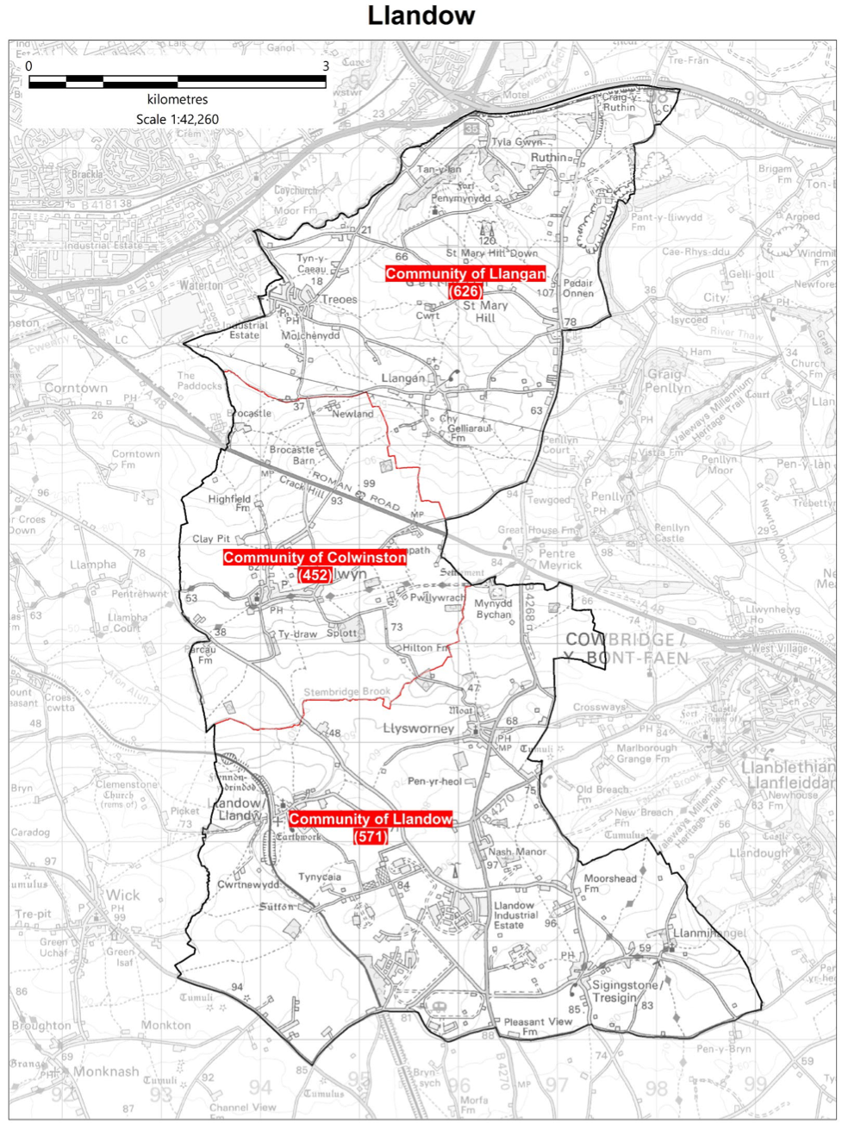

Cllr. Christine Cave email: cacave@valeofglamorgan.gov.uk

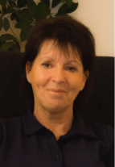

**Date: May /June 2025** Report to the Community Councils (CC) in the Llandow Ward: Colwinston; Llandow, Llysworney, Sigingstone, Sutton and Llangan/Treoes and St Mary Hill.

**Vale of Glamorgan Full Council meeting date to 2025 to April 2026**

14th July, 2025

            29th September, 2025

            1st December, 2025

9th March, 2026

            27th April, 2026.

**Members of the Cabinet**

Councillor L. Burnett (Executive Leader and Cabinet Member for Performance and Resources) – **Labour Party**

Councillor B.E. Brooks (Deputy Leader and Cabinet Member for Sustainable Places) – **Labour Party**

Councillor R.M. Birch (Cabinet Member for Education, Arts and the Welsh Language) – **Labour Party**

Councillor M.R. Wilson (Cabinet Member for Neighbourhood and Building Services) **Labour Party**

Councillor M.R. Wilkinson (Cabinet Member for Public Sector Housing and Tenant Engagement) **Labour Party**

Councillor E. Williams (Cabinet Member for Social Care and Health) **Llantwit First Party**

Councillor S. Sivagnanam (Cabinet Member for Community Engagement, Equalities and Regulatory Services) **Labour Party**

Councillor G. John (Cabinet Member for Leisure, Sport and Well-being) **Llantwit First Party**

**Cabinet meetings June 2025**

**5th and 19th June 2025**

**AGENDA 5th June 2025**

**Part 1**

**1.         Apologies for absence.**

**2.         Minutes of the Meeting held on** [22nd May, 2025](https://www.valeofglamorgan.gov.uk/Documents/_Committee%20Reports/Cabinet/2025/25-05-22/Minutes.pdf)**.**

**3.         To receive declarations of interest and the nature of such interests under the Council’s Code of Conduct.**

 ***(Note: Members seeking advice on this item are asked to contact the Monitoring Officer or Democratic Services at least 48 hours before the meeting).***

**Report of Meeting –**

4.         Cardiff Bay Advisory Committee – [30th April, 2025](https://www.valeofglamorgan.gov.uk/Documents/_Committee%20Reports/Cabinet/2025/25-06-05/CBAC-Minutes-30-Apr-25.pdf).

**Report of the Executive Leader and Cabinet Member for Performance and Resources –**

5.         [Corporate Concerns and Complaints Policy Review](https://www.valeofglamorgan.gov.uk/Documents/_Committee%20Reports/Cabinet/2025/25-06-05/Corporate-Concerns-and-Complaints-Policy-Review.pdf).

**Report of the Cabinet Member for Neighbourhood and Building Services –**

6.         [Five Mile Lane](https://www.valeofglamorgan.gov.uk/Documents/_Committee%20Reports/Cabinet/2025/25-06-05/Five-Mile-Lane.pdf) – Extension of Land Agent Contract and Capital Programme Revisions.

**7.         Any items which the Chair has decided are urgent (Part I).**

**PART II**

**THE PUBLIC AND PRESS MAY BE EXCLUDED FROM THE MEETING DURING CONSIDERATION OF THE FOLLOWING ITEM(S) IN ACCORDANCE WITH SECTION 100A(4) OF THE LOCAL GOVERNMENT ACT 1972.**

**Report of the Cabinet Member for Neighbourhood and Building Services**

8.         Five Mile Lane – Extension of Land Agent Contract and Capital Programme Revisions.

**9.         Any items which the Chair has decided are urgent (Part II).**

**Cabinet meetings May 2025**

1st May (already reported) and 22nd May 2025

**22nd May 2025**

**Agenda**

1.         Apologies for absence.

[[View Minute](https://www.valeofglamorgan.gov.uk/Documents/_Committee%20Reports/Cabinet/2025/25-05-22/Minutes.pdf)]

2.         Minutes of the Meeting held on [1st May, 2025](https://www.valeofglamorgan.gov.uk/Documents/_Committee%20Reports/Cabinet/2025/25-05-01/Minutes.pdf).

[[View Minute](https://www.valeofglamorgan.gov.uk/Documents/_Committee%20Reports/Cabinet/2025/25-05-22/Minutes.pdf)]

3.         To receive declarations of interest and the nature of such interests under the Council’s Code of Conduct.

*(Note: Members seeking advice on this item are asked to contact the Monitoring Officer or Democratic Services at least 48 hours before the meeting).*

[[View Minute](https://www.valeofglamorgan.gov.uk/Documents/_Committee%20Reports/Cabinet/2025/25-05-22/Minutes.pdf)]

Reference –

4.         [Quarter 3 Revenue Monitoring 2024/25](https://www.valeofglamorgan.gov.uk/Documents/_Committee%20Reports/Cabinet/2025/25-05-22/Ref-from-LC-Q3-Revenue-Monitoring.pdf) – Learning and Culture Scrutiny Committee: 31st March, 2025.

[[View Minute](https://www.valeofglamorgan.gov.uk/Documents/_Committee%20Reports/Cabinet/2025/25-05-22/Minutes.pdf)]

Report of Meeting –

5.       [Joint Consultative Forum](https://www.valeofglamorgan.gov.uk/Documents/_Committee%20Reports/Cabinet/2025/25-05-22/JCF-Mins-31-Mar.pdf) – 31st March, 2025.

[[View Minute](https://www.valeofglamorgan.gov.uk/Documents/_Committee%20Reports/Cabinet/2025/25-05-22/Minutes.pdf)]

Reports of the Executive Leader and Cabinet Member for Performance and Resources

6.        [Strategic Collaborative Working Initiatives Update.](https://www.valeofglamorgan.gov.uk/Documents/_Committee%20Reports/Cabinet/2025/25-05-22/Strategic-Collaborative-Working-Initiatives.pdf)

[[View Minute](https://www.valeofglamorgan.gov.uk/Documents/_Committee%20Reports/Cabinet/2025/25-05-22/Minutes.pdf)]

7.         [Appointments to Outside Bodies / Joint Committees.](https://www.valeofglamorgan.gov.uk/Documents/_Committee%20Reports/Cabinet/2025/25-05-22/Appointments-to-Outside-Bodies.pdf)

[[View Minute](https://www.valeofglamorgan.gov.uk/Documents/_Committee%20Reports/Cabinet/2025/25-05-22/Minutes.pdf)]

Report of the Deputy Leader and Cabinet Member for Sustainable Places –

8.         [Reshaping Services – Assets and Opportunities for Concessions.](https://www.valeofglamorgan.gov.uk/Documents/_Committee%20Reports/Cabinet/2025/25-05-22/Assets-and-Opportunities-for-Concessions.pdf)

[[View Minute](https://www.valeofglamorgan.gov.uk/Documents/_Committee%20Reports/Cabinet/2025/25-05-22/Minutes.pdf)]

Report of the Cabinet Member for Leisure, Sport and Well-being –

9.         [Mural at the Richard Taylor Memorial Skate Park](https://www.valeofglamorgan.gov.uk/Documents/_Committee%20Reports/Cabinet/2025/25-05-22/Mural-at-Richard-Taylor-Memorial-Skate-Park.pdf), Located at the Knap, Barry.

[[View Minute](https://www.valeofglamorgan.gov.uk/Documents/_Committee%20Reports/Cabinet/2025/25-05-22/Minutes.pdf)]

10.      Any items which the Chair has decided are urgent (Part I).

**Current consultations**

**Placemaking**

Welcome to our Placemaking hub, a platform for you to share your views on how to improve our town...

View Project

<https://participate.valeofglamorgan.gov.uk/hub-page/placemaking>

**Play area improvements**

The Grange Open Space, Wenvoe

<https://www.valeofglamorgan.gov.uk/en/our_council/consultation/Play-Area-Improvements.aspx>

**Submit a petition (including e-petition)**

Creating or taking part in a petition is one way you can get involved in what the Council does. It allows you to raise issues of concern, giving Councillors the opportunity to consider the need for change.

[Create or sign a petition](https://participate.valeofglamorgan.gov.uk/e-petition)

**Local Matters**

## Colwinston - Adoption of the vines– further contact made with Miles Punter (easements signed) waiting confirmation from Persimmon Homes.

* Colwinston – Village Hall roof repairs - transfer of assets meeting village hall - ongoing
* Colwinston – Clarification of the VoG C’s public Space Protection Order – dog fouling in public open spaces – information provided and consultation likely in coming months - ongoing
* Colwinston – S106 affordable housing spend agreed for Cowbridge conversion of the former Police Station and redevelopment of the former Magistrates Courts on Westgate into over 55+ affordable residential apartments - completed
* Colwinston – Missing sign in Colwinston – reported and ongoing
* Colwinston – State of roads in the village reported – waiting inspection report – ongoing
* Colwinston – Green waste bags delivered (as requested)
* Colwinston – matters related to replacement clerk – ongoing
* Colwinston – planning matter taken up with planning department – completed
* Colwinston - partial cut of the grass verge in Church Lane – matter raised – ongoing
* Colwinston – Road resurfacing criteria - ongoing
* Llandow – Glue Pot Bridge – work almost complete
* Llandow – Potholes/road subsidance reported Llantwit Road – ongoing
* Llandow – Signage issue reported (Kart Kingdome) - ongoing
* Llandow – Sigingstone planning matter raised and further consultation requested - ongoing
* Llandow – Field run off – water related issues – meeting took place in Llandow Village Hall on the 12th February 2025 – a number of useful outcomes including thanks to National Resources Wales, Welsh Water and the Vale of Glamorgan Council officers for doing work in the village to ensure the village is unlikely to suffer from the negative consequences of heavy rainfall in the future. Further work is needed with the farming community to assist with limiting the amount of field water runoff etc. A sub meeting will be held in the next few months with local landowners/farmers and others to facilitate a shared understanding of ways of working that support the local everyone living and working in the local community - ongoing
* Llandow – Planning Application 2024/01030Full Proposed Caravan and Camping Site on farming land - ongoing
* Llandow – Poor state of the play area in Llandow – ongoing
* Llandow – Sigingstone – clearing of the pond – meeting arrangements taking place for July - ongoing
* Llandow – Sigingstone Memorial Service – fund raising efforts and garden - ongoing
* Llangan – Speeding traffic is an ongoing issue – ongoing
* Llangan – potholes reported - ongoing
* Llangan – Notification of roposed No Stopping at any time except Police vehicles Layby fronting Llangan Primary School – notification agreed
* Llangan – litter and fly tipping reported from allotments in Treoes to the top of A48 – reported ongoing.

Scheduled meetings for June 2025- All Meetings commence at 6.00 p.m. and will be held virtually unless otherwise stated.

|  |  |  |  |
| --- | --- | --- | --- |
| Council |  | Early Retirement/Redundancy  (10.00 a.m.) |  |
| Annual Meeting |  | Licensing - Public Protection  (10.00 a.m.) | 10 Jun |
| Cabinet (2.00 p.m.)    [[View Live Stream - 5 June](https://youtube.com/live/M99Byui-V3I)] | [5 Jun](https://www.valeofglamorgan.gov.uk/en/our_council/Council-Structure/minutes,_agendas_and_reports/agendas/cabinet/2025/25-06-05.aspx);  19 Jun | Licensing - Statutory |  |
| Scrutiny (Resources) |  | Licensing Sub (10.00 a.m.)    [[View Live Stream - 5 June](https://www.youtube.com/live/dUJ3Fo_uJrM?si=YwMpVnbX1aXyXdMK)] | [5 Jun](https://www.valeofglamorgan.gov.uk/en/our_council/Council-Structure/minutes,_agendas_and_reports/agendas/licensing_sub/2025/25-06-05.aspx) |
| Scrutiny (Start Well) |  | Planning (4.00 p.m.)    [[View Live Stream - 12 June](https://youtube.com/live/kuNztt1yV_w?feature=share)] | [12 Jun](https://www.valeofglamorgan.gov.uk/en/our_council/Council-Structure/minutes,_agendas_and_reports/agendas/planning/2025/25-06-12.aspx) |
| Scrutiny (Live Well) |  | Public Rights of Way |  |
| Scrutiny (Place) |  | Senior Management Appointment |  |
| Appeals |  | Standards (10.00 a.m.) |  |
| Governance and Audit | 23 Jun | Trust |  |
| Community Liaison |  | Vale of Glamorgan Local Access Forum |  |
| Democratic Services (4.00 p.m.) | 30 Jun | Voluntary Sector Joint Liaison | 16 Jun |
| Investigating |  | Welsh Church Act Estate (4.00 p.m.) | 2 Jun  24 Jun |
|  |  | Shared Regulatory Services Joint Committee  (10.00 am) | 18 Jun  25 Jun |